Chapter 10 | Data Displays
Date: | Lesson 10.4 Box-and-Whisker Plots
Essential Question | How can you use quartiles to represent data graphically?
Key Idea  Box-and Whisker Plot | A box-and-whisker plot ____________________________________________  ___________________________________________________________________  ___________________________________________________________________  The five numbers that make up the box-and-whisker plot are called the _____________________________________
Making a Box-and- Whisker Plot | 1) The data shows how many hours each friend spent online last night. Make a box-and-whisker plot for the data.  1, 0, 2, 3, 4, 3, 6, 1, 0, 1, 2, 2  Step 1: Order the data. Find the median and the 1st and 3rd quartiles.  Step 2: Draw a number line atha includes the least and greatest values.  Step 3: Draw a box using the quartiles. Draw a line through the median. Draw whiskers fro the box to the least and greatest values.
Key Idea | How data is distributed in a box-and-whisker plot:
Analyzing a Box-and- Whisker Plot | 2) The box-and-whisker plot shows the body mass index (BMI) of a sixth grade class.  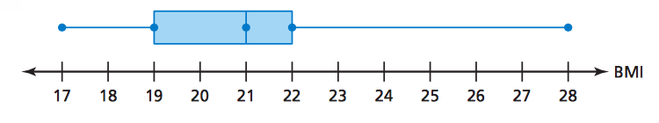  a) What fraction of the students have a BMI of at least 22?  ________________________________________________________________________  ________________________________________________________________________  ________________________________________________________________________  b) Are the data more spread out below the first quartile or above the third quartile?  ________________________________________________________________________  ________________________________________________________________________  ________________________________________________________________________  c) Find and interpret the interquartile range.  ________________________________________________________________________  ________________________________________________________________________  ________________________________________________________________________
Key Idea | 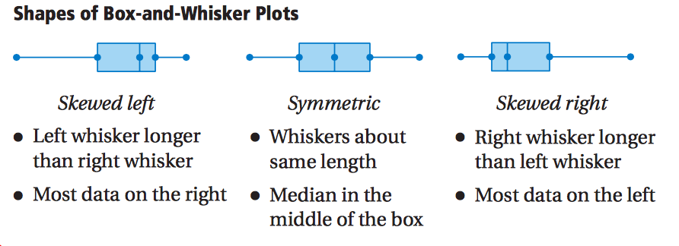
Comparing Box-and- Whisker Plots | 3) The double box-and-whisker plot represents the prices of snowboards at two stores.  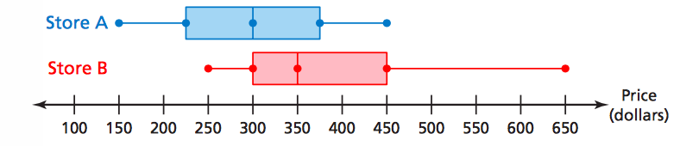  a) Identify the shape of each distribution.  ________________________________________________________________________  ________________________________________________________________________  ________________________________________________________________________  ________________________________________________________________________  ________________________________________________________________________  ________________________________________________________________________  ________________________________________________________________________  b) Which store’s prices are more spread out? Explain.  ________________________________________________________________________  ________________________________________________________________________  ________________________________________________________________________  ________________________________________________________________________  ________________________________________________________________________  ________________________________________________________________________

